|  |
| --- |
| **Rural Liquor Vendor**  **Merchandising and**  **Shelf Management Philosophy** |
|  |
|  |
|  |
|  |

|  |
| --- |
|  |

**TABLE OF CONTENTS**

**The Peak Period Promotion Program…………………………………….p. 3**

**Limited Release Beer Program……………………………………………p. 5**

**Contests……………………………………………………………………….p. 6**

**Shelf Talkers………………………………………………………………….p. 7**

**New Products…………………………………………………………………p. 8**

**Limited Time Offer Program……………………………………………….p. 9**

**Premium Spirit Sale…………………………………………………………p. 10**

**Limited Release Program ………………………………………………….p. 11**

**In-Store Sampling Program……………………………………………….. p. 12**

**Shelf Management Philosophy………………………………………………p. 14**

**Glossary of Terms…..………………………………………………………….p. 21**

**Liquor Vendor Standard Product Signage ………………………………. p. 24**

**Appendix A ………………………………………………………………………p. 26**

***Note that programs may change during the year.***

**The Peak Period Promotion Program**

The Peak Period Promotion Display Program provides the opportunity for suppliers to display products in prime locations for a period of four weeks.

**APPLICATION**

An email application process will be required to be included in the program. MBLL will send this application out for each program to all Liquor Vendors.

***All participation applications must be submitted on or before the deadline date*.**

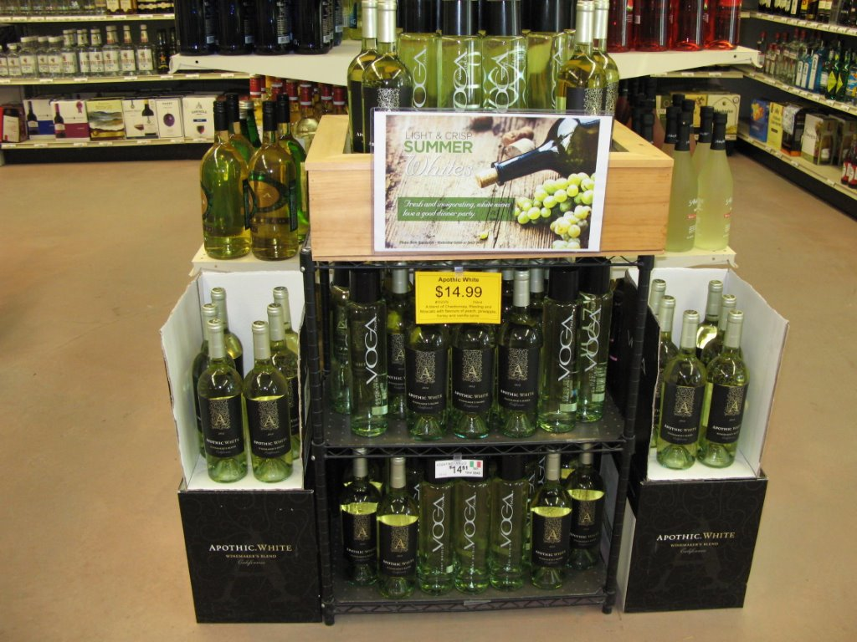

* **PARTICIPATION**

All listed products that are on the top sellers list or any new arrival products that are performing well in the market (excluding economy) are eligible for Peak Period Promotion.

**SELECTION CRITERIA FOR DISPLAYS**

* Top seller list
* Top selling new arrivals in market
* Overall balance of displays
* Support of other marketing suppliers during the period
* Projected sales volume
* Seasonality
* Preference given to Premium and Deluxe brands

**NUMBER OF SKUs AND INVENTORY**

Displays will consist of no more than two related SKUs for spirits, wine, beer, and refreshment.

* For wine there will be a minimum of 3 cases of each participating brand unless otherwise approved.
* For Spirits there will be a minimum of 2 cases of each participating brand unless otherwise approved.
* For beer and refreshment there will be a minimum of 3 cases of each participating brand unless otherwise approved.
* Sufficient inventory should be maintained to support visually effective displays.

**Per Sku Max**

|  |  |
| --- | --- |
| Product | Case Quantity |
| Wine | 3 |
| Spirits | 3 |
| Refreshment & Beer | 3 |

**STORE DISPLAY SET-UP**

Liquor Vendors should have displays completed within two days of the period commencement. The display can be taken down immediately after the last day of the program.

* **PROGRAM AND MATERIALS GUIDELINES**

All promotional materials will be provided by MBLL in consultation with the participating suppliers.

* **P.O.P. SIGNAGE**

Signage (Legal size) for the display will be produced by Manitoba Liquor and Lotteries.

Signage will be “seasonally appropriate”, relevant to all products in the display and clearly communicate a “reason to buy”. Pricing information may not appear on the sign.

**Limited Release Beer Program**

The Limited Release Beer Program provides the opportunity for Liquor Vendors to bring in limited availability beers for a limited time. The intention of this program is to create excitement in the beer areas of your stores, and to increase the revenue in your locations.

**APPLICATION**

An email application process will be required to be included in the program. MBLL will send this application out for each program to all Liquor Vendors. There are a limited number of beers available for each program so first come first serve.

***All participation applications must be submitted on or before the deadline date.***

**PARTICIPATION**

The participating beers are limited availability and are not available to order. Limited number of cases is brought into the province for a short term sell thru.

**EXPECTATION OF STORE PARTICIPATION**

This program is intended to enhance your beer sales and assortment. All participating stores must display the product in a prime location in the beer area of store or in the fridge.

**SIGNAGE**

A price card will be supplied by MBLL. The price card will include tasting notes and product information.

**CONTESTS**

Suppliers may use contests to promote their products. Contests executed by suppliers are not connected to Manitoba Liquor & Lotteries.  Suppliers are responsible for compliance with all laws and regulations and shall save Manitoba Liquor & Lotteries harmless from any actions resulting from a dispute involving a supplier run contest.

It is the supplier’s responsibility to ensure the contest, and any promotion or advertising associated with the contest, comply with all applicable laws, regulations and guidelines, including specifically the guidelines established below:

*a) All contestants must be 18 years of age or over;*

*b) The contest must be legal in accordance with all federal, provincial and municipal legislation,*

*c) The prize(s) offered must be within the limits of good taste and propriety,*

*d) Contest rules must state that MBLL is not connected with the contest in any manner whatsoever and are not liable in any way whatsoever with respect to any matter relating to the contest,*

*e) Contests conducted in Liquor Vendors must be approved by the Manitoba Liquor & Lotteries*

*f) A prize of liquor is prohibited.*

*g) Ballot boxes, ballots & pens/pencils must be supplied if required.*

***Suppliers should advise Manitoba Liquor and Lotteries for contest approval.***

**SHELF TALKERS**

The Shelf Talker Program provides the opportunity for suppliers to place shelf talkers and neck tags at the regular shelf location of the respective item for a period of time.

The creative must be professionally produced and must contain MEANINGFUL information, i.e. Food pairings, drink recipes, accolades, information about the product. Dimensions should not exceed 4” x 5” for shelf talkers, and 3” x 5” for neck tags.

**PARTICIPATION**

All listed products are eligible for Shelf Talkers

**SELECTION CRITERIA**

Selection will be made based on seasonality, sales objectives and overall assortment. The total number of shelf talkers and neck tags may be limited. It is the supplier's responsibility to ensure that all creative elements are compliant with regulations.

**GENERAL GUIDELINES**

All shelf talkers should always be placed to the right of the price ticket, hanging downwards.

LTO shelf talkers should cover the price ticket.

**NEW PRODUCTS**

Any new productintroduced into a store's assortment should be identified as a new product.

All new products should be incorporated into the store layout consistent with the criteria outlined in the Shelf Management section of this manual. Any new product incorporated into a store layout must be maintained for a minimum of six months.

Any new product introduced into a store's assortment should be identified by a "NEW ARRIVAL" shelf strip. The life of a new product has been established as 30 days. After 30 days, the new product shelf talkers & strips will be removed.

**LIMITED TIME OFFER PROGRAM**

The Limited Time Offer Program allows Liquor Vendors the ability to provide short-term discount to their customers.

LTO periods run in two-week, non-overlapping periods beginning on a Monday and terminating on a Sunday. The Marketing Program Schedule outlines the timing of the LTO events.

**PARTICIPATION**

All listings are eligible for the program. Economy products are not eligible, with exception of spirits which are allocated based on sales volumes. Spirits smaller than 400mls are not eligible for participation. Economy liqueurs are eligible.

**DISTRIBUTION**

Products on the program will be available to order 1 week prior to the start of program with no limit on the purchase per customer.

**LTO SELECTION CRITERIA**

There will be a maximum number of items selected for each LTO Period.

Upon review by the Purchasing Department, LTO’s may be rescinded if it is determined that the product may not arrive in a timely fashion.

**PRICING**

The following pricing guidelines apply:

* All products participating on LTO that are carried in your location must be marked with the LTO price.
* Stores may use the supplied LTO signage, or create their own as long as sale price and regular price are displayed.

**SHELF TALKERS**

Liquor Vendors will be supplied with blank shelf talkers for use in their outlets

**PREMIUM PRODUCT LTO –NOVEMBER 16-29, 2015**

Only products deemed to be "premium" or better will be accepted for this LTO.

|  |  |  |  |  |  |
| --- | --- | --- | --- | --- | --- |
|  | | | | | |
|  |  |  |  |  |  |

**PREMIUM SPIRIT SALE**

The Premium Spirit Sale offers Liquor Vendors an opportunity to promote premium and deluxe spirits during the 2-week February 8-21, 2016 timeframe.

**PARTICIPATION**

The Spirit Sale is intended for Premium and Deluxe Core spirits (rye, rum, vodka, gin, scotch, etc.). **We encourage that at least one SKU from each Premium and Deluxe brand set participate (i.e. 750ml, 1140ml, or 1750ml).**

**PRICING**

The following pricing guidelines apply:

* All products participating on LTO that are carried in your location must be marked with the LTO price.
* Stores may use the supplied LTO signage, or create their own as long as sale price and regular price are displayed.

**LIMITED RELEASE PROGRAM**

**OBJECTIVES**

To add excitement to our Liquor Vendors shopping experience while offering exceptional value to our retail customers on a limited opportunity basis. These items will be purchased and sold in smaller quantities to create a ‘BUY NOW’ experience for Liquor Mart customers.

* **APPLICATION**

An email application process will be required to be included in the program. MBLL will send this application out for each program to all Liquor Vendors. There is only a limited number of beers available for each program so first come first serve.

* **ELIGIBILTY**

Wine and specialty beer only

* **EXECUTION**
* Forced distribution to stores
* Only one case will be sent to participating store
* Prime location near front of liquor area
* Media support and signage will be provided

***NOTE: Limited Release items are only available in limited amounts, and first come first serve.***

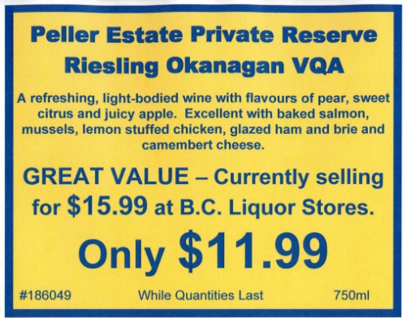

**IN-STORE SAMPLING PROGRAM**

* All listed products are eligible to be sampled.
* Samplings can be conducted by store staff or a marketing representative or their designate.
* A maximum of two products are allowed for a sampling.
* Taste samples will be provided without charge to the customer and in quantities not greater than contained in the following guidelines:

|  |  |  |
| --- | --- | --- |
| **Product** | **Ounces** | **Millilitres** |
| Wine | 2 oz. | 60mls |
| Spirits & Liqueurs | ½ oz. | 15mls |
| Cider, Beer & Coolers | 4 oz. | 120mls |

* The use of merchandising and customer information materials are permissible.
* It is recommended that you provide crackers, or bread during the sampling to allow customer to cleanse pallet.
* Product can be purchased by a supplier for a sampling to be held at your store.
* The sampler must not leave supplies of opened product unattended at any time.
* Samplers should have knowledge of the product they are sampling

**PLACEMENT**

* Higher priced products should be placed on the highest shelving, with lower priced products on lower shelves.
* In keeping with store shelf layouts, rosé wines should be mixed in with whites, and sparkling wines should be grouped together.
* Liquor Vendors may have refrigeration units located in the liquor area of the store offering a selection of chilled product.

**SPACE ALLOCATION**

* Wine: 30% of the space allocated should be occupied by each store’s bestselling brands and should include a selection of bag-in-box wines (popular priced over $9.00 per 750ml equivalent).
* Beer: At least 30% of the space allocated space should be committed to Manitoba Liquor & Lotteries distributed beer.
* Refreshment Beverages: 40% of the space allocated should be occupied by top selling premium and deluxe refreshment beverages.

**ELIGIBILITY**

* Popular priced wines below $9.00 (750ml equivalent) should not be included in the cold box.

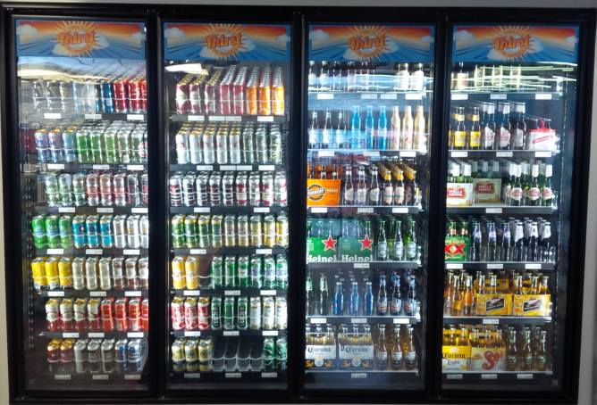

**SHELF MANAGEMENT PHILOSOPHY**

**OBJECTIVE**

Shelf management augments customer service, inventory management, sales goals and premiumization. Product Category Classifications (As defined by Category Management).

|  |  |  |  |
| --- | --- | --- | --- |
| Spirits | Refreshment Beverages | Beer | Wine (based on 750ml format) |
| Deluxe | Deluxe | Deluxe | Over $23.00 |
| Premium | Premium | Premium | $20.00 to $22.99 |
| Economy | Economy | Economy | $17.00 to $19.99 |
|  |  |  | $14.00 to $16.99 |
|  |  |  | $11.00 to $13.99 |
|  |  |  | $8.00 to $10.99 |
|  |  |  | Under $7.99 |

**Subject to change

**OVERALL PRODUCT LOCATION**

Liquor Mart products are merchandised using the following:

* Wire gondola fixtures (usually three high)
* Wire wall fixtures (usually five high)
* Millwork
* Display cases
* Packages beer & high volume coolers may be floor-stacked.
* **RESOURCES**

Your Sales Manager can provide you with sales reports to assist in determining your purchases in last 6 – 12 months.

Appendix A in the liquor vendor guidelines will provide you the specific information related to:

* Minimum number of listings
* Top seller expectations
* Refrigeration expectations

**SPIRITS/LIQUEURS LOCATION**

* The highest volume category furthest from the entrance – usually Canadian Whisky.
* Where possible, use “colour separation” i.e. dark vs white spirits
* Keep section boundaries within natural shelf dividing posts as much as possible
* Spirit and liqueur categories will be sub-categorized. The subcategories will be the following:
  + Canadian Whisky
  + American/Irish

*Ideally American & Irish should be adjacent to Canadian.

**Scotch whisky: malts**

* Highland
* Lowland
* Islay
* Blends

**Vodka: regular flavoured**

**Brandy: cognac brandy**

**Rum:**

* White
* Dark
* Flavoured

**Gin**

**Tequila**

**Miscellaneous Spirits:**

* Akvavit
* Others

In some instances these sub-categories will be further segmented into classifications (e.g. Economy, Premium, and Deluxe).

Liqueurs are blocked together by subcategory (e.g. cream liqueur) or brand set (e.g. Malibu).

**Half bottle sections**

375ml bottles of spirits will be “bill boarded” together, by category, with the best-selling categories on primary shelves. EXCEPTION: All deluxe spirits will be shelved with their parent brand.

**POSITIONING**

Wherever possible, brands will be displayed using a billboard effect. The billboard effect, created by putting all the 750ml/1140ml and 1750ml etc. of a brand together, will create an effective brand presentation and create potential for improved sales in the premium category and for up sizing. Sizes are displayed together, side by side, above & below each other, or in a “billboard” incorporating “right-hand trade-up”, i.e. largest size to the right. The billboard will also include any logical brand extensions, i.e. CC Classic. The price of a 750ml of a brand or brand set will dictate the product’s location, horizontally. The other sizes and any brand extensions will be associated in accordance with this document. Where space permits, stores will have a minimum of 2 facings for all products, with the exception of some high-price brands (Cognac, Single Malts).

**PREMIUM & DELUXE PRODUCTS**

Deluxe and Premium brands will occupy reach level shelving (top shelves), with the highest priced products occupying the highest shelves. If variations in pricing exist within the Deluxe or Premium classification the lowest priced products will occupy the lower shelves. Deluxe products will have a minimum 2 facings subject to space availability and with the exception of some higher-priced products (single malts, cognac, etc).

**ECONOMY PRODUCTS**

If variations in pricing exist within the Economy classification the lowest priced products will occupy the bottom shelf, regardless of the brand’s sales (see sample planograms on back pages ).

**CATEGORY SPACE**

Generally speaking, each category should be allocated space in a ratio to its sales. For example, if the rum category accounts for 15% of spirits’ sales, it should receive 15% of the spirit space. HOWEVER, consideration must be given to the number of category SKUs, e.g. Liqueurs require more space than sales dictate due to the number of SKUs required to maintain an adequate assortment. Conversely Canadian whisky may require less space.

**BRAND / SKU SPACE**

Ideally, each SKU is given the minimum facings required for holding 30% of an average month’s public sales on the shelf. For lower volume brands, there should be sufficient shelf space to hold inventory equivalent to a case. Exceptions can be made for unusual package sizes

**WINE LOCATION**

General Principals

* Regions/countries with the highest (per litre equivalent) price point will be placed on shelving toward the front of the store to capitalize on SKU profitability.
* The lowest profit country categories should occupy the least desirable locations.

**BRAND / SKU SPACE**

Each SKU will be given space commensurate with its sales volume. For lower volume brands, there should be sufficient shelf space to hold inventory equivalent to a case. Ideally, there should be no more than 5 SKUs to a shelf. Exceptions can be made for unusual package sizes and store space constraints.

**Fortified Wine**

* Separate subcategories i.e.,
* Sherry
* Port
* Vermouth
* Miscellaneous

**Table Wine**

* Separate by country
* Separate Canadian wines by BC VQA, Ontario VQA, and Blended & Bottled in Canada
* Separate by bill boarded brand set – i.e. Jackson-Triggs, Wolf Blass
* Within each category segment, products should be grouped together according to price classifications.
* Wines should be laid out by price classification, with the highest price classification first, according to traffic flow.
* Within the space allotted for each price classification, prices should flow from high (top shelves) to low (bottom shelves).

- Economy intended for bottom shelf only.

**Sparkling Wine**

* Separate by Champagne, import, domestic

**POSITIONING**

Brand sets are placed in a “billboard” incorporating “right-hand trade-up”, i.e. largest sizes to the right. Location of a brand will be dictated by sales of the “consumer size” (750ml) or, if no 750ml, the “quasi consumer size” (1.5L).

**REFRESHMENT BEVERAGES**

**LOCATION**

* Higher volume brands will be stacked in the refreshment beverage area with lower volume brands on shelving
* Separate by malt-based, spirit coolers, wine coolers, ciders, freezer pouches & RTD.
* Separate by subcategories
  + Deluxe
  + Premium
  + Economy
  + Separate by brand

**BEER – PACK SIZES**

**LOCATION**

General Principles

* Beer will be merchandised in Refreshment Beverage Areas.
* “Packaged Beer”
* Separate by subcategories
  + Deluxe
  + Premium
  + Economy

The classifications are Deluxe, Premium, Economy and single unit.

**No privately distributed SKUS permitted to be sold in Liquor vendors unless MBLL has approved.**

**POSITIONING**

Deluxe and premium products in the category will be displayed first, according to traffic flow. Brands sets are placed together.

**Single unit beer**

* Organize beer by country, and by price point
* The lowest profit country categories should occupy the least desirable locations

**Glossary of terms:**

**Bill boarding** – *Grouping of products in a set to form a block or rectangular display of a brand or brand set, giving the visual impression of a billboard.*

**Brand** -, *i.e., Crown Royal, Bacardi White Rum, [ yellow tail ], Sawmill Creek*

**Brand Set** – *A set of products sharing the same brand name. – i.e., Jackson Triggs is the brand name; the varietal wines when combined on the shelf would form the Brand Set.*

**Category** – *Rum, Vodka, Liqueurs, Canadian wines, etc.*

**Classifications** – *Economy, Popular, Premium, Deluxe, etc.*

**Millwork** – *Custom made finished woodwork*

**Subcategory** – White Rum, Cream Liqueurs, Canadian varietal wines, etc.

**Listing Types:**

**General** – *products that have potential for significant sales. These items are auto reordered and have the greatest store distribution. General listings are judged against their direct competition in terms of sales objectives.*

**Sample Planograms**

*These planograms are conceptual and are intended as concepts which apply to our philosophy for shelf management*

**POSITION ACCORDING TO PRICE FIRST, THEN SALES**

**NOTE: Transition shelf (if required) will vary from category to category depending on the number of SKUs in each price classification.**

* **Canadian Whisky, Rum – White, Dark, Light, Vodka**

|  |  |  |  |  |
| --- | --- | --- | --- | --- |
| Highest price | 1 | Deluxe | 1 | Highest price |
|  | 2 | Premium | 2 |  |
|  | 3 | Premium | 3 |  |
|  | 4 | Low priced premium >Economy | 4 |  |
| Lowest price | 5 | Low priced Economy | 5 | Lowest price |

* **Gin**

|  |  |
| --- | --- |
| 1 | Deluxe |
| 2 | Premium |
| 3 | Low priced Premium |
| 4 | Economy |
| 5 | Low priced Economy |

**Single Malts Blended Scotch**

|  |  |  |  |  |
| --- | --- | --- | --- | --- |
| Highland | Highest price | Deluxe | 1 | Highest price |
| Highland |  | Premium | 2 |  |
| Highland | Lowest price | Low priced Premium | 3 |  |
| Lowland |  | Economy | 4 |  |
| Islay |  | Low priced Economy | 5 | Lowest price |

**Cognac Brandy**

|  |  |  |  |  |
| --- | --- | --- | --- | --- |
| Cognac | 1 | Deluxe | 1 | Highest price |
| Cognac | 2 | Premium | 2 |  |
| Cognac | 3 | Premium >Economy | 3 |  |
| Cognac | 4 | Economy | 4 |  |
| Cognac | 5 | Economy | 5 | Lowest price |

**Liqueurs**

|  |  |  |  |  |  |
| --- | --- | --- | --- | --- | --- |
| Coconut | Orange | Coffee/Choc | Cream | Cream | Fruit |
| Coconut | Orange | Coffee/Choc | Cream | Cream | Fruit |
| Nut | Herbal | Coffee/Choc | Cream | Cream | Fruit |
| Nut | Herbal | Coffee/Choc | Cream | Cream | Fruit |
| Nut | Herbal | Coffee/Choc | Cream | Cream | Fruit |

**WINE**

**By Price**  **by Price**

|  |  |  |  |  |  |  |  |
| --- | --- | --- | --- | --- | --- | --- | --- |
| Deluxe | Super Premium | Premium | Premium |  | Popular | Popular | Popular |
| Ultra Premium | Super Premium | Premium | Premium |  | Popular | Popular | Popular |
| Ultra Premium | Premium | Premium | Premium |  | Popular | Economy | Economy |

**Appendix A**

**IN-STORE SAMPLINGS**

**SUPPLIER / SAMPLER GUIDELINES**

**Supplier Responsibilities**:

* Ensure proper and adequate supply of recyclable sampling glasses, ice, cooler, garbage bags, etc., and if sampling wine, provide bread and/or crackers.
* May provide promotional items with signage conveying giveaway.
* Provide sampler with adequate product information.
* Verify times and locations just prior to execution date.
* Ensure sampler is aware of their responsibilities (outlined below).

**Sampler Responsibilities**:

* Must be 18 years of age or older
* Arrive in presentable attire.
* Avoid using a cell phone (voice or text) on the sales floor.
* Must identify oneself to management or designate.
* Samplers should taste product in the staff area (kitchen/office), and not on the sales floor.
* Must request ID if customer appears to be 25 years of age or younger.
* Must not provide a sample to anyone who is less than 18 years of age.
* Must not provide a sample to anyone who appears to be intoxicated.
* Must be able to provide information about the product being sampled. Make no comparisons to a competitor’s brand.
* Open product and empties should be turned over to manager or designate at the end of each day’s sampling. Used sampling glasses must be recycled.
* No sampler under any circumstances can remove sampled product from the store.
* Samplers are considered to be representing Liquor Marts and must follow management direction.
* A sampler who reports more than 30 minutes late for a sampling may not be able to set up